In Odoo, **domains** are used to filter records based on specific conditions. They are commonly used in search filters, computed fields, and record rules.

**🔹 Step 1: Understanding Domain Syntax**

A domain in Odoo is a list of tuples, where each tuple follows this format:



Each tuple consists of:

1. **Field Name** – The database field to filter.
2. **Operator** – A comparison operator (=, !=, <, >, like, etc.).
3. **Value** – The value to compare the field against.

Example:

This filters records where the state field is **'done'**.

**🔹 Step 2: Common Domain Operators**

Here are some commonly used operators in Odoo domains:

| **Operator** | **Meaning** | **Example** |
| --- | --- | --- |
| = | Equal to | [('state', '=', 'done')] |
| != | Not equal to | [('state', '!=', 'draft')] |
| > | Greater than | [('price', '>', 100)] |
| < | Less than | [('price', '<', 500)] |
| >= | Greater than or equal to | [('quantity', '>=', 10)] |
| <= | Less than or equal to | [('quantity', '<=', 5)] |
| like | Contains substring | [('name', 'like', 'Odoo')] |
| ilike | Case-insensitive contains | [('name', 'ilike', 'odoo')] |
| in | Value exists in a list | [('state', 'in', ['done', 'cancel'])] |
| not in | Value not in a list | [('state', 'not in', ['draft'])] |
| child_of | Includes children in hierarchy | [('category_id', 'child_of', 3)] |

**🔹 Step 3: Using Domains in Different Places**

**✅ 1. In Search Views**

Domains are used in XML to filter records in search views.  
Example:

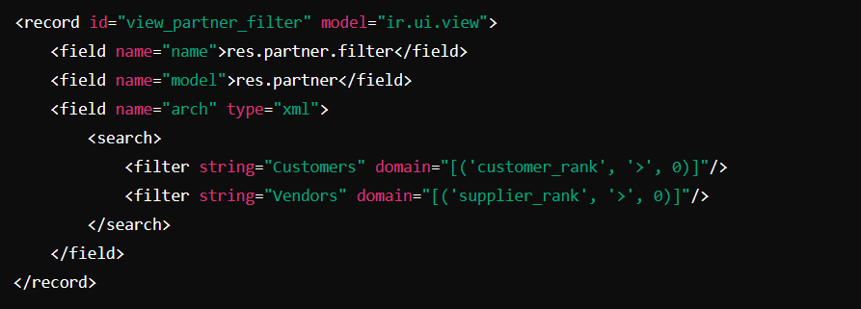

**✅ 2. In Python (Record Search)**

You can use domains in Python when searching for records.



**✅ 3. In Fields (Default Filters)**

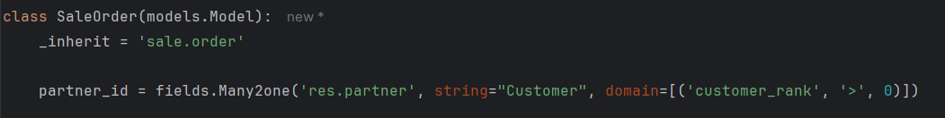This ensures that only **customers** appear in the partner_id selection.

**✅ 4. In Record Rules (Access Control)**

Domains can be used in **record rules** to control access.

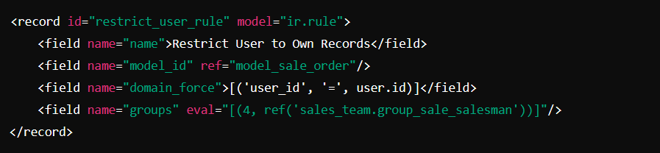This ensures that **salespeople** can only see their own records

**🔹 Step 4: Combining Multiple Conditions**

**✅ AND Condition (Default Behavior)**

By default, conditions in a domain are combined using **AND**.



This filters records where:

* state is **done**
* amount_total is **greater than 1000**

**✅ OR Condition (| Operator)**

To combine conditions with **OR**, use a **pipe (|)** before conditions.

This filters records where:

* state is **draft** OR **sent**.

**✅ Complex Conditions**

You can combine multiple conditions using & (AND) and | (OR).



This means:

* state is **done** OR **sent**
* AND amount_total is **greater than 1000**

**🔹 Step 5: Testing Domains in Odoo**

To test a domain in Odoo, you can:

1. **Use the Developer Mode**
   * Open Odoo
   * Activate **Developer Mode**
   * Go to a model (e.g., Sales Orders)
   * Use the "Search" feature and apply filters manually.
2. **Use the Python Console**  
   Run the following in Odoo's shell:
3. env['sale.order'].search([('state', '=', 'done')])

**🎯 Conclusion**

Domains are powerful tools in Odoo that allow you to filter records efficiently. You can use them in: ✔ Search views  
✔ Fields with domain restrictions  
✔ Record rules for access control  
✔ Python code for querying data